**Use Cases+**

**Use case scenario 1 - Customer booking a court**

**Instance 1: Blue skies scenario**

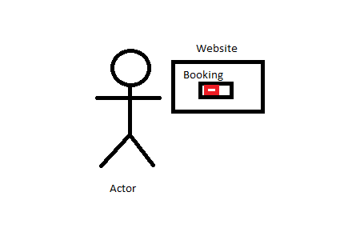

**Description:** the actor which is a customer of the rec centre is trying to book a court on the rec centre website instead of booking through the rec centre receptionist.

**Assumptions:**

The Actor is a member of the rec centre, so the actor is able to do booking on the website. (Same for the other instances).

**Pre-conditions:**

The actor has logged in on his account on the rec centre website. (Same for the other instances).

**Steps:**

1. The customer/actor selects the court they want to book
2. The customer sees the available times for the court they want to book and based on this knowledge, they select the the time they want and is currently available to book.
3. The system acknowledges the booking by an alert popping up saying that the actor has successfully booked the court at the time that they chose.

**Post-conditions:**

The customer/actor has successfully booked a court through the rec centre website and is able to go to the specific court and time that the actor chose.

**Benefiting actor:**

The actor and the rec centre receptionist (does not have to book it manually for the customer).

**Instance 2: Unsuccessful booking**

**Steps:**

1. The customer/actor selects the court they want to book
2. The customer sees the available times for the court they want to book, but tries to book a time that is already booked.

**Post-conditions:**

The system acknowledges the unavailable booking by an alert popping up saying that the time selected is unavailable and to try to book a different time or a different court.

**Instance 3: Wrong time slot selected**

**Steps:**

1. The customer/actor selects the court they want to book
2. The customer sees the available times for the court they want to book, but accidentally selects and confirms the the wrong time slot.
3. The system acknowledges the booking by an alert popping up saying that the actor has successfully booked the court at the time that they chose.

**Post-conditions:**

The customer/actor has to email/dial the rec centre receptionist to either cancel the booking or change the time of the booking they initially selected.

**Use case scenario 2-customer trying to sign up for membership.**

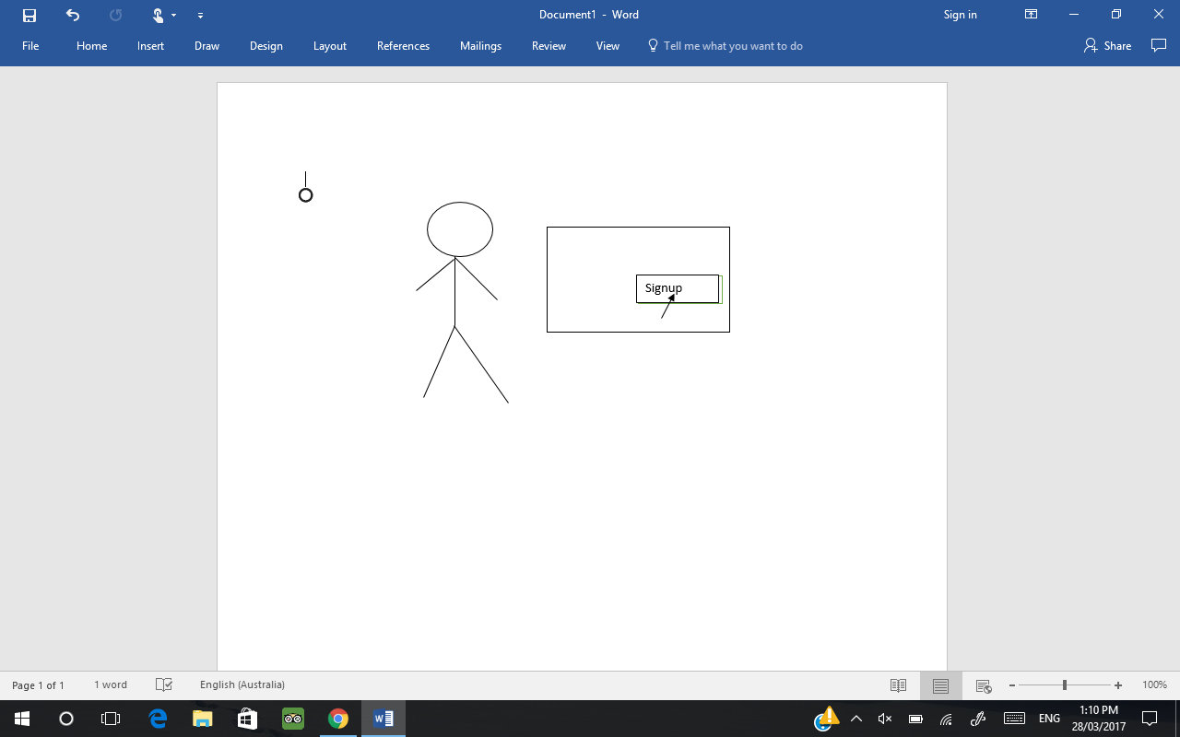

**Instance 1: Blue skies scenario**

**Description:** The actor which is the customer has heard about the rec centre and is signing up for the subscription.

**Assumptions:**

The customer has contacted different rec centres and determined this one may be able to suit their needs the best.

**Pre-conditions:**

The customer has a stable internet condition to complete the signup process.

**Steps:**

1. The customer chooses their username and password
2. The customer enters their email address
3. The customer selects the type of membership they want
4. The customer enters their credit card details and confirms the details
5. An email is sent the customer with a link they click to confirm their registration is proper

**Post Condition:**

The customer has successfully signed up to the rec centre and can access the facilities and make purchases.

**Benefiting factor:**

The actor benefits because they now have access to the rec centre, but the rec centre also benefits as they have another customer to provide their service to and make the money they need to keep providing the service to others.

**Instance 2: Card type not accepted**

**Steps:**

1. Actor/Customer enters their payment method which is a mastercard.
2. The customer submits the information but the system says that the card type is not supported when it is a option in the payment method.

**Post Condition:**

The customer was unable to pay so they contacted the rec centre and told them the problem. They give him the first month subscription for free and fix the problem on there end.

**Benefiting factor:**

The rec centre are the main party that benefits as they found out about the problem earlier rather than later and were able to fix it. They also helped the customer and admitted it was their problem and not the customers. Now the customer is there three or four times a week and has a 12 month subscription.

**Instance 3 Password not accepted:**

**Steps:**

1. A customer tries subscribing for a three month subscription and enters all their details.
2. The system says password does not match requirements and must be eight characters long with a special character and capital letter.
3. THe customer tries this but again does not accept the password.

**Post Condition:**

The customer contacts the rec centre and they say it was the customers fault because he was clicking login instead of signup. He hangs up and the re centre take the login button away from the subscription service.

**Use case scenario 3 - Customer allocating gym sessions/classes**

**Instance 1: Blue skies scenario**

**Description:** The actor which is the customer of the rec centre is attempting to attend multiple gym classes by going through the website to allocate the classes.

**Assumptions:**

The Actor has the membership required for the rec centre, so the actor is able to log on, view and allocate gym classes through the website. (Same for the other instances).

**Pre-conditions:**

The customer must have a rec centre account and a stable internet connection to successfully view and select the preferred classes to join.

**Steps:**

1. The customer goes on the website and views the classes offered.
2. The customer could identify the classes that he/she wants to attend. The customer then decides based on the information such as type of class, duration of class and available timeslots that are given.
3. The system acknowledges the changes with a pop up alert confirming the action and the actor has successfully allocated his/her selected gym classes to attend to.

**Post-conditions:**

The customer/actor has successfully booked the classes through the rec centre website and attend the classes.

**Benefiting actor:**

The customer does not have to physically go to the rec centre and register with the receptionist. The rec centre receptionist does not have to allocate the classes and help the customer as it was done manually by the customer.

**Instance 2: Unsuccessful registration/allocation**

**Steps:**

1. The customer selects the classes he/she want to book.
2. The customer sees the time slots available for the classes they want to book, and tries to book for the preferred slot.
3. The customer chose the preferred class but was unsuccessful due to the class being full.

**Post-conditions:**

The system replied with an error pop-up stating that the class session is unavailable as it is full and gave other options on the empty slot sessions for the current class.

**Instance 3: Clash of gym classes**

**Steps:**

1. The customer selects the classes that he/she wants to attend.
2. The customer sees the time slots available for the classes they want to book, and tries to book for the preferred slots.
3. The website shows that the time slots for the chosen classes are available, but the classes are clashing with one another therefore making the customers attempt to have multiple classes in one day unsuccessful.

**Post-conditions:**

The rec centre advised the customer on the other time slots for the classes on different days and helped building a personal session that accommodates to the customer’s schedule preference.